Name : **Akhilesh kumar**

Project: **Capstone Project Relational Database**

Topic : **ChatGPT GitHub**

link:

# **Product Dissection for ChatGPT**

**Company Overview**: ChatGPT is an artificial intelligence language model developed by OpenAI, an organization focused on advancing artificial intelligence in a safe and beneficial manner. OpenAI was founded in December 2015 and is based in San Francisco, California. The organization's mission is to ensure that artificial general intelligence (AGI) benefits all of humanity.

# **Product Dissection and Real-World Problems Solved by ChatGPT** :

**Product Dissection**: It has been trained on a diverse range of internet text to understand and generate human-like text across various domains.

Here are some key aspects of ChatGPT's product dissection:

1. **Architecture:** ChatGPT is based on a transformer architecture, specifically GPT-3.5, which includes numerous layers of attention mechanisms and neural networks. This architecture allows ChatGPT to understand context, generate coherent responses, and perform a wide range of natural language processing tasks.
2. **Training Data**: ChatGPT has been trained on a massive dataset consisting of internet text from books, articles, websites, forums, and more. This diverse training data enables ChatGPT to have a broad

understanding of language, including colloquialisms, slang, technical terminology, and domain-specific knowledge.

1. **Fine-Tuning and Adaptability**: ChatGPT can be fine-tuned and adapted to specific tasks or domains, allowing developers and users to customize its responses and capabilities. This makes ChatGPT versatile and applicable across various industries and use cases.

**Real-World Problems Solved by ChatGPT**:ChatGPT has been used to address a wide range of real-world problems and applications across different domains. Some examples include:

1. Customer Support: ChatGPT can assist with customer inquiries, provide information about products or services, troubleshoot common issues, and offer personalized recommendations.
2. Content Generation: ChatGPT can generate creative content such as articles, stories, poems, code snippets, and more based on user inputs or prompts.
3. Educational Tools: ChatGPT can act as a virtual tutor, answering questions, explaining concepts, and providing learning resources for students and educators.
4. Healthcare Assistance: ChatGPT can help answer medical queries, provide information about symptoms and treatments, and offer general health advice.
5. Language Translation: ChatGPT can assist with language translation tasks, helping users communicate across different languages and cultures.
6. Chatbots and Virtual Assistants: ChatGPT can power chatbots and virtual assistants for businesses, organizations, and platforms, enhancing customer interactions and automating routine tasks.

# **Case Study: Real-World Problems and ChatGpt Innovative Solutions**

**Case Study 1: AI-Powered Customer Support Chatbot**

Problem Statement: A company receives a high volume of customer inquiries and support tickets across multiple channels, leading to long response times and overwhelmed support teams. Customers expect fast and accurate responses to their queries, leading to a need for efficient customer support solutions.

**Innovative Solution with ChatGPT**:

1.Automated Responses: ChatGPT can power an AI chatbot that handles common customer inquiries and support requests. The chatbot can understand customer questions, provide relevant information, troubleshoot issues, and escalate complex cases to human agents when needed.

2.24/7 Availability: The AI chatbot powered by ChatGPT operates round the clock, ensuring that customers can receive assistance at any time, reducing wait times and improving customer satisfaction.

3. Integration with CRM Systems: The chatbot seamlessly integrates with the company's customer relationship management (CRM) systems to access customer data, track interactions, and provide personalized support based on customer history and preferences.

Benefits:

Improved Response Times Cost Savings

Scalability

**Case Study 2: AI-Powered Content Generation Tool**

Problem Statement: A content creation team struggles to generate high- quality and engaging content at scale, leading to content production bottlenecks and delays. There is a need for a solution that can assist in generating creative and relevant content across various formats and topics.

**Innovative Solution with ChatGPT**:

1. Content Ideation: ChatGPT can assist content creators in generating ideas for articles, blog posts, social media content, marketing copy, and more. It can suggest topics, headlines, and angles based on trending keywords, audience interests, and SEO considerations.
2. Content Generation: ChatGPT can generate draft content based on user inputs, prompts, or outlines. It can create cohesive and well- structured content, including paragraphs, bullet points, product descriptions, and storytelling elements.
3. Language Style Customization: ChatGPT's language model can adapt its writing style and tone to match the brand voice, target audience, and content requirements. It can produce content in formal, informal, persuasive, informative, or conversational styles as needed.

Benefits

Content Efficiency Creativity Boost Consistency

**Some of the top features of ChatGPT**:

1. Natural Language Understanding: ChatGPT can understand and process natural language input, allowing for conversational interactions with users.
2. Content Generation: It can generate human-like text for a variety of purposes, including writing articles, stories, code, and more.
3. Question Answering: ChatGPT can answer questions based on the information it has been trained on, providing accurate and relevant responses.
4. Language Translation: It supports translation between different languages, helping users communicate across language barriers.
5. Text Summarization: ChatGPT can summarize long pieces of text into concise summaries, making it useful for extracting key information from documents or articles.
6. Sentiment Analysis: It can analyze the sentiment of text, identifying whether the tone is positive, negative, or neutral.
7. Contextual Understanding: ChatGPT can understand context within conversations, maintaining coherence and relevance in its responses.
8. Programming Assistance: It can assist with coding tasks by providing code snippets, debugging help, and explanations of programming concepts.
9. Customizability: Users can fine-tune ChatGPT's behavior and responses based on their specific needs and preferences.
10. Integration: ChatGPT can be integrated into various applications and platforms through APIs, enabling seamless interaction with other software systems.

# **Schema Description**:

A schema description of ChatGPT typically includes the following components:

1. Input Layer: This is where text data or queries are fed into the model for processing. Inputs can vary from simple sentences to complex questions or commands.
2. Preprocessing Module: The input data undergoes preprocessing steps such as tokenization, normalization, and encoding to prepare it for the model's understanding. This module ensures that the text is in a format that the model can work with effectively.
3. Transformer Architecture: ChatGPT is based on a transformer architecture, specifically the GPT (Generative Pre-trained Transformer) architecture. This includes layers of attention mechanisms and feedforward neural networks that enable the model to understand and generate text in a coherent manner.
4. Contextual Embeddings: During processing, the model generates contextual embeddings for each token in the input text. These embeddings capture the semantic meaning and context of words within the text, allowing the model to produce meaningful responses based on the input.
5. Attention Mechanisms: The attention mechanisms in the transformer architecture help the model focus on relevant parts of the input text while generating responses. This enables ChatGPT to maintain coherence and relevance in its conversations.
6. Decoding Module: Once the input text is processed and contextual embeddings are generated, the decoding module uses these embeddings to generate output text. This includes predicting the next word or token in a sequence, leading to the generation of coherent and human-like responses.
7. Output Layer: The output layer produces the final output, which could be in the form of text responses, translations, summaries, or other tasks depending on the specific use case of ChatGPT.
8. Fine-Tuning and Adaptation: ChatGPT can be fine-tuned and adapted to specific tasks or domains by adjusting its parameters, training on domain-specific data, or incorporating task-specific objectives during training. This allows the model to perform better on specialized tasks and produce more accurate and tailored responses.

# **ER Diagram**:

1 Entities:

User:

* Attributes:
  + UserID: A unique identifier for each user (Primary Key).
  + Username: The name chosen by the user for identification.
  + Email: The email address associated with the user's account.
  + Password: Encrypted password for user authentication.
  + Profile Picture: Image representing the user's profile.

Conversation:

* Attributes:
  + ConversationID: Unique identifier for each conversation (Primary Key).
  + Start Date: Date and time when the conversation started.
  + End Date: Date and time when the conversation ended (if applicable).
  + Participants: List of UserIDs of users participating in the conversation.

Message:

* Attributes:
  + MessageID: Unique identifier for each message (Primary Key).
  + ConversationID: Foreign key referencing the Conversation entity.
  + SenderID: Foreign key referencing the User entity, representing the sender of the message.
  + Content: Text content of the message.
  + Timestamp: Date and time when the message was sent.

1. Relationships:
   * User - Conversation (One-to-Many):
     + A user can participate in multiple conversations, but each conversation has multiple participants.
   * Conversation - Message (One-to-Many):
     + A conversation can have multiple messages, but each message belongs to one conversation.
   * Knowledge Base Entry - Response (One-to-Many):
     + An entry can have multiple responses, but each response is associated with one entry.
2. Additional Entities (Optional):

Model Configuration: Represents the specific configuration or settings of the ChatGPT model being used.

Training Data: Represents the data used to train and fine-tune ChatGPT. Contextual Embeddings: Represents the embeddings generated by ChatGPT during text processing.

1. Relationship Cardinality:

User interacts with ChatGPT: Many users can interact with many instances of ChatGPT.

Input Text is processed by ChatGPT: Each input text is processed by one instance of ChatGPT.

ChatGPT generates Output Text: Each input text generates one output text or response.

These entities, attributes, and relationships allowing users to engage in conversations, exchange messages, access a knowledge base, and provide

responses to entries in the ChatGPT system .

An ER diagram visually represents these entities, relationships, attributes, and cardinalities in a structured format, providing a clear overview of how data flows and interacts within the ChatGPT system.

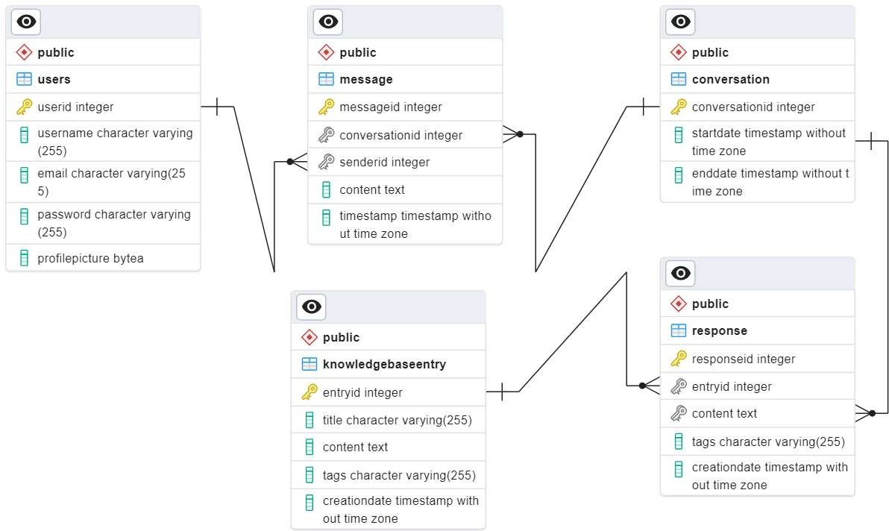

**Conclusion**

In conclusion, ChatGPT is an advanced natural language processing model with a range of innovative features and capabilities. It excels in tasks such as natural language understanding, content generation, question answering, language translation, text summarization, sentiment analysis, and more. Its transformer architecture, including attention mechanisms

and contextual embeddings, enables it to process and generate text in a coherent and contextually relevant manner.

ChatGPT's impact extends across various industries and domains, offering solutions to real-world problems by enhancing communication, improving efficiency, enabling automation, and supporting decision- making processes. Despite its strengths, ChatGPT also faces challenges such as bias in language models, privacy concerns, and the need for continuous improvement and ethical development.

Looking ahead, the future of ChatGPT appears promising with ongoing advancements in AI technology, increased adoption across industries, and a focus on ethical AI practices. As ChatGPT continues to evolve and adapt, it is poised to play a significant role in shaping the future of human-AI interactions and addressing complex challenges in society.